Shapefile Creation and Sentinel Trim - QGIS Walkthrough

- Have these on system
  - A new folder to put any new files you create in QGIS
  - One Sentinel-2 .tif file
  - US Bureau Census county shapefile zip
    - https://www.census.gov/geographies/mapping-files/time-series/geo/carto-boundary-file.html
    - Specifically the cb_2018_us_county_500k.zip
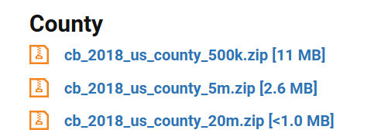
    - Unzip

- IF you are just uploading an already trimmed Huron Shapefile to use, and are not creating it:
  - (Skip this step if you want to create it on your own)
  - When you upload the shapefile, it might appear to be filled with color
  - Layer Panel → Right-click cb_2018 layer → Properties → On the sidebar, click Symbology → Simple Fill → Fill Style → No Brush → OK

- Steps for creating Huron shapefile
- Open QGIS
- On the top ribbon → Layer → Add Layer → Add Vector Layer
- When the box opens → File → Vector Dataset(s) → Click [...] button → Select the cb_2018_us_county_500k.shp file from the unzipped folder. Only the .shp file should be used → Add
- Go to Layer Panel on left side of screen → Right-click cb_2018 layer → Filter… → Type STATEFP='26' AND NAME='Huron' into bottom box → OK
- Layer Panel → Right-click cb_2018 layer → ‘Zoom to Layer’
- Huron should appear as a colored-in shape
- Layer Panel → Right-click cb_2018 layer → Properties → On the sidebar, click Symbology → Simple Fill → Fill Style → No Brush → OK
- Huron should be transparent now with only a black boundary line.
- Layer Panel→ Right-click cb_2018 layer → Export → Save features as… → Format = ESRI Shapefile → File name [...] save to your files
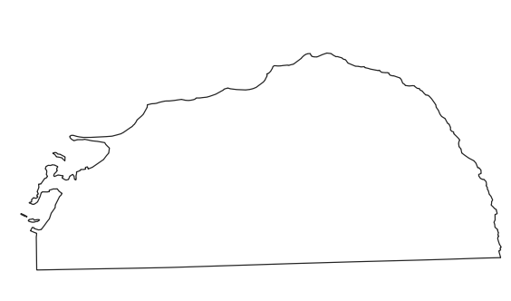

- Steps for overlaying and trimming Sentinel-2 image to Huron Shapefile
- On the top ribbon → Layer → Add Layer → Add Raster Layer
- When the box opens → File → Raster Dataset(s) → Click [...] button → Select your Sentinel-2 .tif file → Add
- A box titled ‘Select Transformation’ should pop up → Look at the ‘Accuracy (meters)’ column and choose the one with the lowest number (and therefore higher accuracy) → Close out box after
- On the top ribbon → Processing → Toolbox → In the search bar type in ‘Clip Raster by Mask Layer’
- Input Layer = Sentinel-2 tif file → Mask Layer = the Huron Shapefile (click box and it will pop up easy) → Check-mark both ‘Match the extent of the clipped raster to the extent of the mask layer’ AND ‘Keep resolution of input raster’ → Scroll down → Clipped (mask) field = save it as .tif in your files [..] → Run
- Layer Panel → Uncheck original .tif file so it disappears
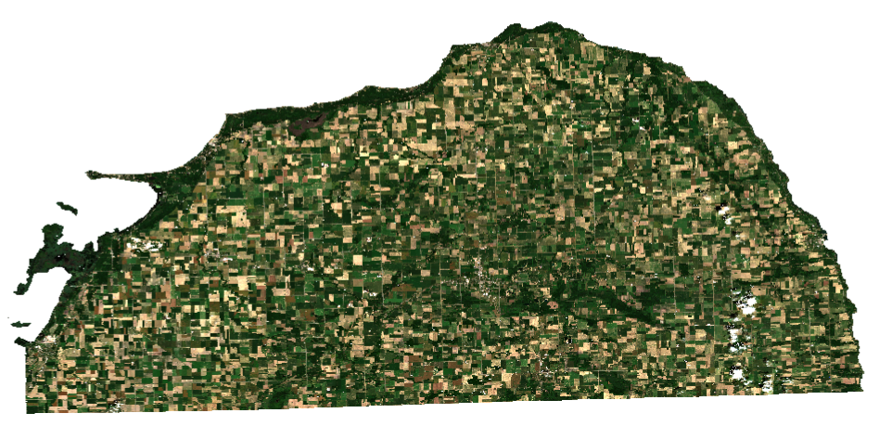
- Clipped Sentinel-2 image should appear

